Adam Mohmoud
AZ-900 Fundamentals
Virtual Machine Azure CLI Lab
Mohmoud.adam@gmail.com

In this lab, I created a Virtual Machine (VM) with the Azure Command-Line Interface (CLI) to deploy and manage virtual machines, streamlining the process of VM provisioning and configuration in Azure.

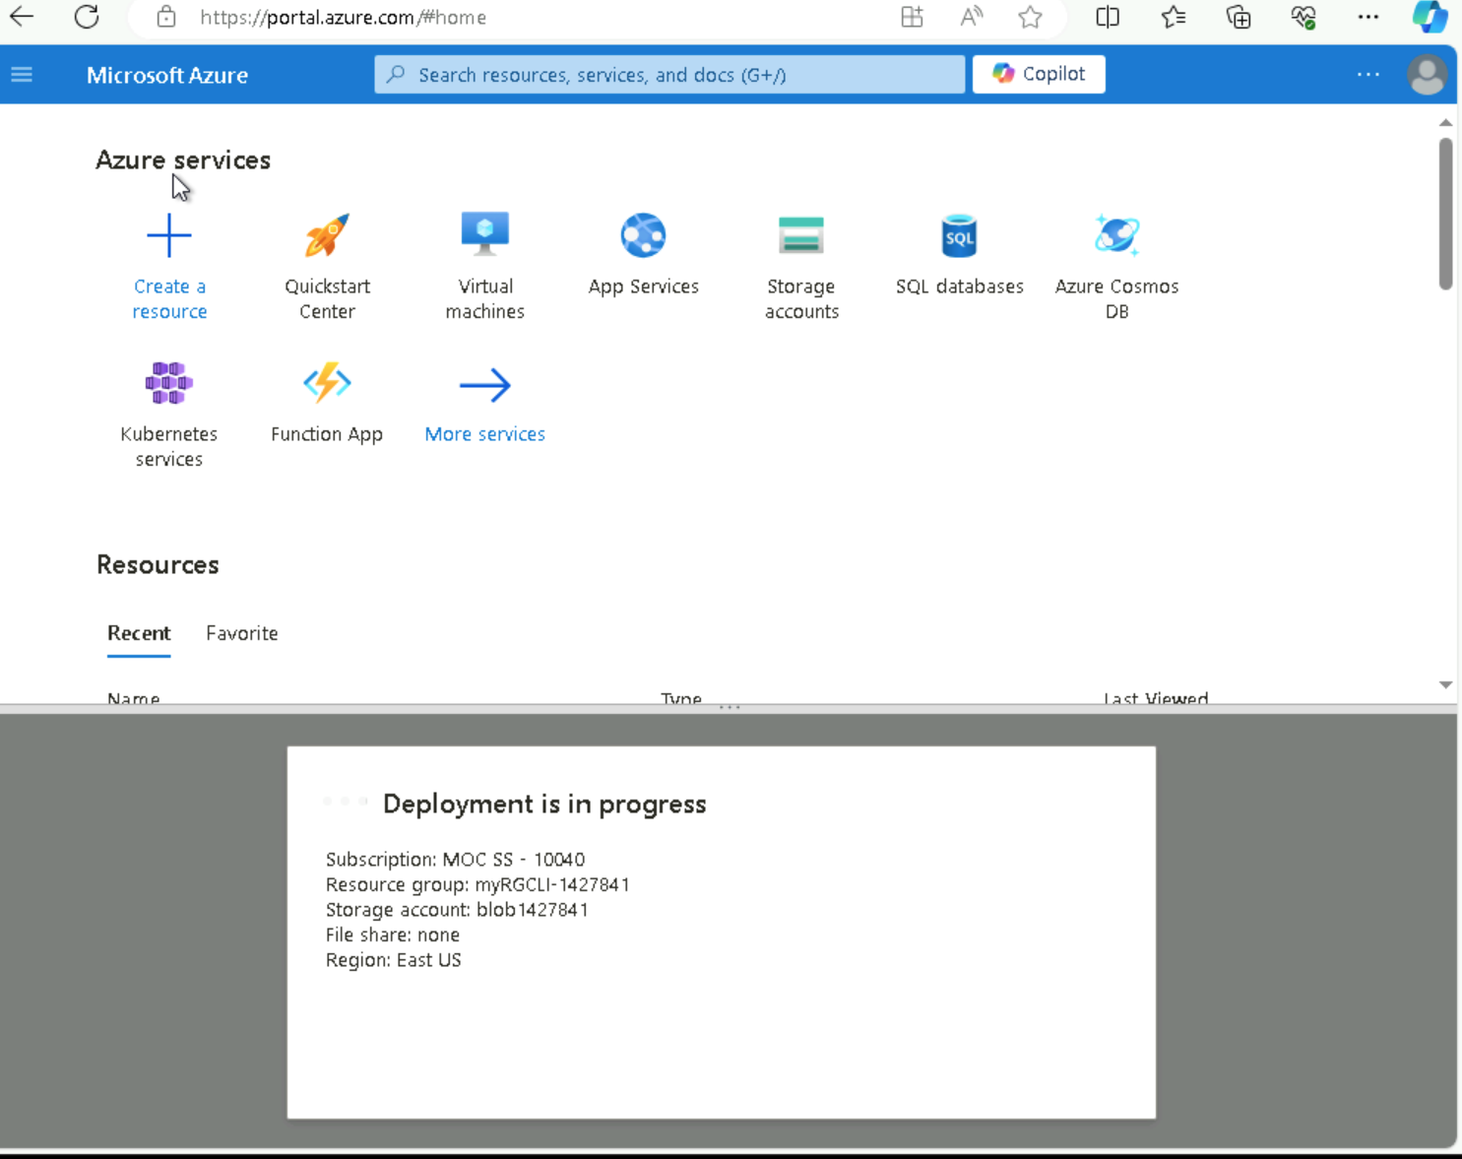

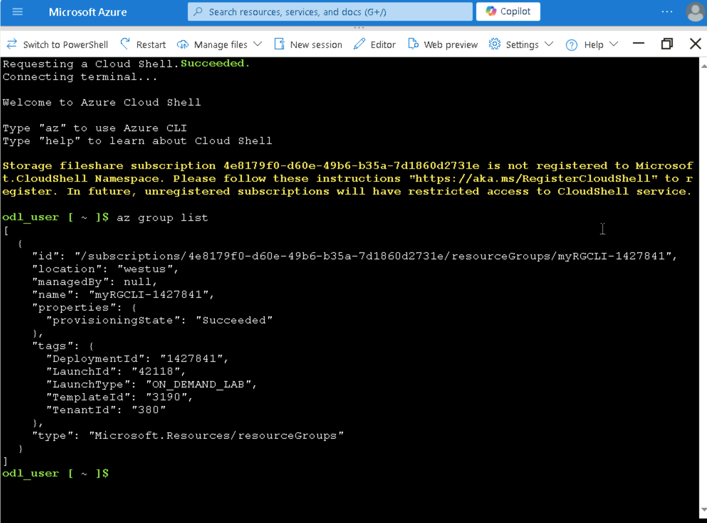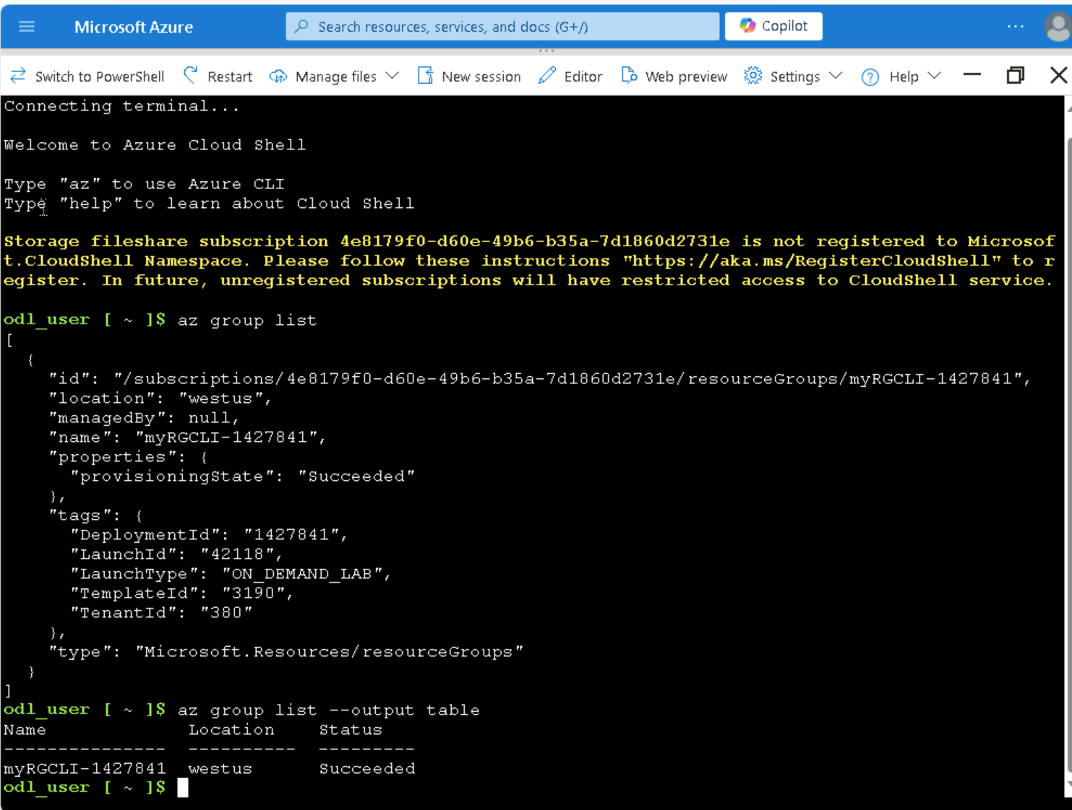

In the Bash session, within the Cloud Shell pane, I will get the existing resource group “az group list”. I will proceed to format the group listing output “az group list --output table”
After creating a new VM I wrote as followed on the command line:
az vm create \
--name myVMCLI \
--resource-group myRGCLI-1427841 \
--image Win2019Datacenter \
--location EastUS \
--size Standard_B2s \
--admin-username azureuser \
--admin-password Pa$$w0rd1234
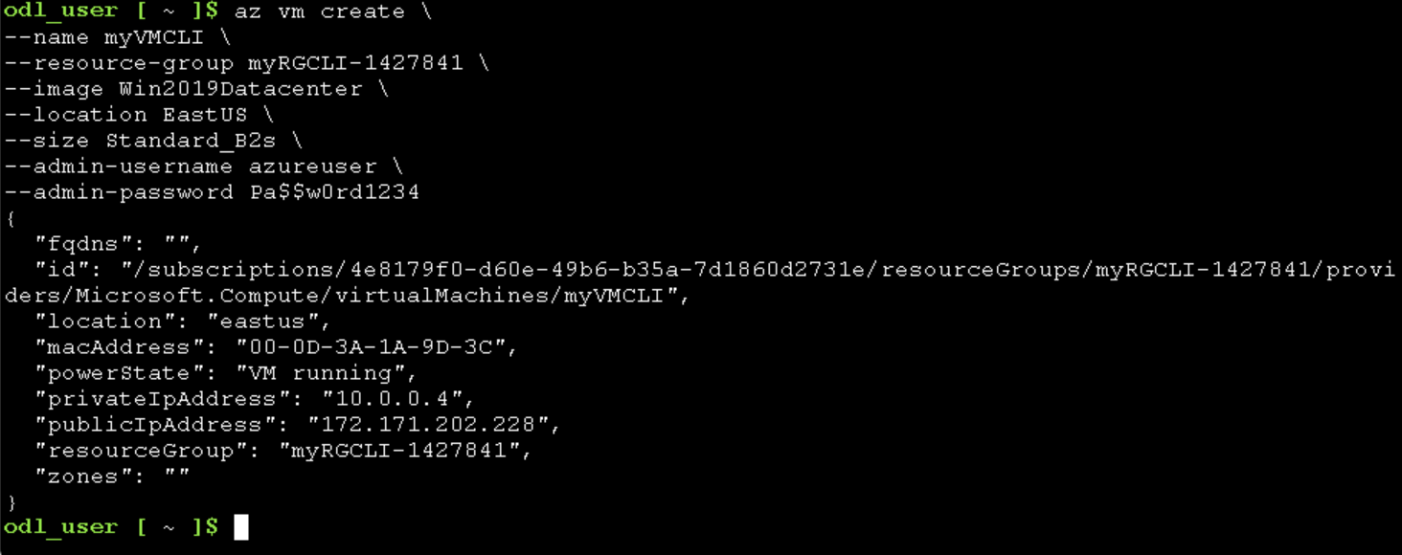
After the command finished, I closed the cloud shell pane and went back to my Azure portal to confirm if “MyVMCLI” is running.
